CASE STUDY:-
AIIMS oncologist decision tree — treatment selection under uncertainty. A patient at AIIMS Delhi has been diagnosed with Stage 2 lung cancer. The oncologist considers 3 treatments: S (surgery), C (chemotherapy), R (radiotherapy). Each has probabilistic outcomes for 5-year survival vs side-effects. Quality-of-life-adjusted utility (QALYs):
S: 0.7 prob → 8 QALY ; 0.3 prob → 1 QALY (surgical complications, death)
C: 0.5 prob → 6 QALY ; 0.5 prob → 3 QALY (chemo side-effects)
R: 0.6 prob → 5 QALY ; 0.4 prob → 4 QALY (radiotherapy fatigue, lower variance)Treatment decision tree · DEC=oncologist · CHANCE=outcome · QALY leaf
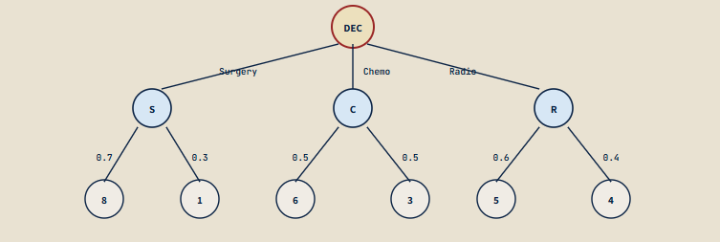
(a) QALY framework + utility theory in medicine. Define QALY (Quality-Adjusted Life Year): 1 QALY = 1 year in perfect health. Discounted for morbidity (e.g., 0.7 QALY/year = 1 year with significant disability). State why QALYs are the standard utility unit in health-economics (NICE UK, ICMR India use them). State limitations: subjectivity in disability weights, ethical debates on age-discrimination, equity vs efficiency.
(b) Compute expected utility for each treatment.
EU(S) = 0.7 × 8 + 0.3 × 1 = ?
EU(C) = 0.5 × 6 + 0.5 × 3 = ?
EU(R) = 0.6 × 5 + 0.4 × 4 = ?
State the recommended treatment under risk-neutral utility. Compute the maximum-expected-utility (MEU).
(c) Risk-aversion analysis. Apply u(QALY) = √QALY (risk-averse). Recompute EU under aversion. Show whether the recommendation changes. Compute the certainty equivalent of S: c such that √c = EU-aversive(S). Compare with E[QALY of S]. State the risk premium = E[QALY] − c. Discuss: when should an oncologist treat patients as risk-averse vs risk-neutral? (Patients usually prefer certainty; risk-aversion may rationally apply.)

(d) Multi-attribute utility. Real treatment decisions involve multiple attributes: survival + quality of life + treatment cost + family burden. State (i) the additive multi-attribute utility model U = w_1 · u_1 + w_2 · u_2 + ... ; (ii) the assumptions required (preference independence, mutual utility independence); (iii) practical elicitation: ICMR Health Technology Assessment guidelines; (iv) the role of patient preferences vs population averages — do we maximise patient's individual utility or population QALY?
SOLUTION:-
Work Done Summary
A decision analysis model was developed for selecting the most appropriate treatment for an AIDS patient under uncertainty using the concept of Quality-Adjusted Life Years (QALYs). Three treatment alternatives were considered:
- Surgery (S)
- Chemotherapy (C)
- Radiotherapy (R)
For each treatment, probabilities of possible outcomes and their corresponding QALY values were identified. A decision tree was constructed to represent the treatment choices and uncertain outcomes. Expected Utility (EU) values were calculated to determine the treatment that provides the highest expected quality-adjusted survival benefit.
Implementation Details
1. Decision Tree Construction

A decision node (DEC) was created with three treatment options:

Surgery (S)
Chemotherapy (C)
Radiotherapy (R)

Each treatment branch leads to chance nodes representing possible outcomes with associated probabilities and QALY values.

2. Utility Assignment
Treatment Probability QALY
Surgery 0.7 8
Surgery 0.3 1
Chemotherapy 0.5 6
Chemotherapy 0.5 3
Radiotherapy 0.6 5
Radiotherapy 0.4 4
3. Expected Utility Calculation

Expected Utility Formula:

EU=∑P(outcome)×Utility(outcome)
Surgery
EU(S)=0.7(8)+0.3(1)
EU(S)=5.6+0.3=5.9
Chemotherapy
EU(C)=0.5(6)+0.5(3)
EU(C)=3+1.5=4.5
Radiotherapy
EU(R)=0.6(5)+0.4(4)
EU(R)=3+1.6=4.6
4. Treatment Selection

The treatment with the highest Expected Utility is selected.

max(5.9,4.5,4.6)=5.9

Therefore:

Optimal Treatment = Surgery

Result
Treatment Expected Utility (QALY)
Surgery 5.9
Chemotherapy 4.5
Radiotherapy 4.6

Selected Treatment: Surgery

Reason: Surgery provides the highest expected quality-adjusted life years (QALYs), indicating the greatest expected benefit to the patient.
Conclusion
The decision analysis demonstrates how Expected Utility Theory and QALYs can support medical treatment decisions under uncertainty. By combining the probabilities of treatment outcomes with their quality-of-life benefits, a quantitative comparison of alternatives was obtained.
Among the three treatment options evaluated, Surgery achieved the highest expected utility of 5.9 QALYs, outperforming Chemotherapy (4.5 QALYs) and Radiotherapy (4.6 QALYs). Hence, based on the decision model, Surgery is the most preferred treatment option. This approach helps healthcare professionals make evidence-based decisions while balancing survival outcomes, quality of life, and treatment risks.

GitHub Link:- https://github.com/gayathrisrivalli0612/DSA-2.git
Student Signature | Faculty Signature
K. Gayathri Srivalli

